EECS 4404

Assignment 3

Anton Sitkovets

Step 1

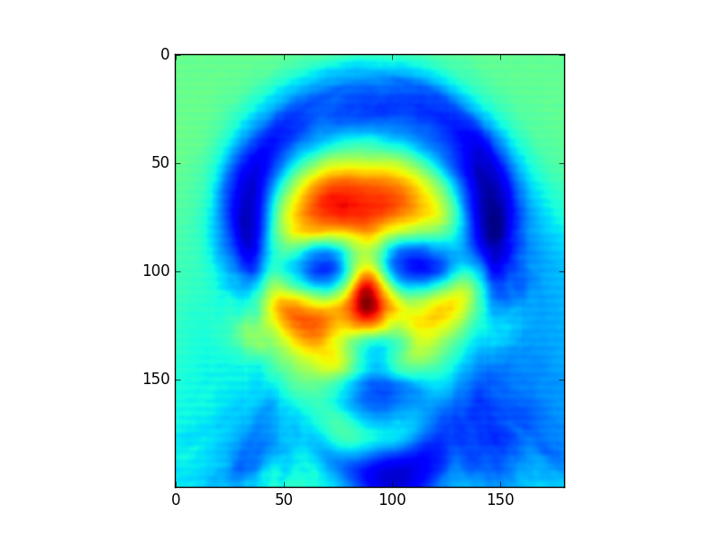

Figure 1. Mean Face of Dataset

Step 2

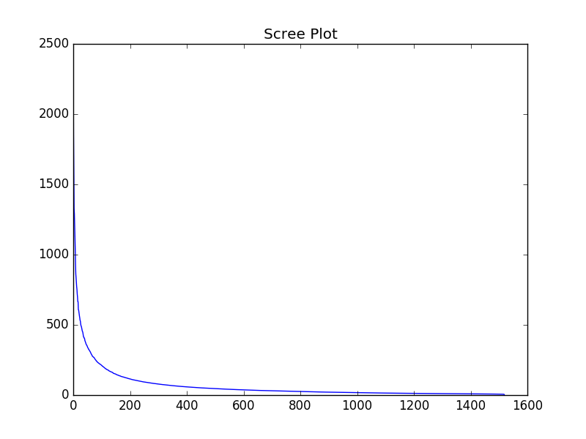

Figure 2. Scree Plot

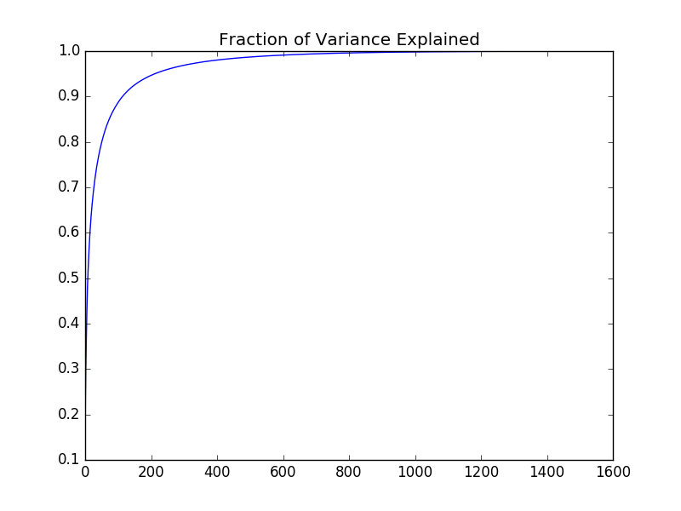

Figure 3. Fraction of Variance for Eigenvalues

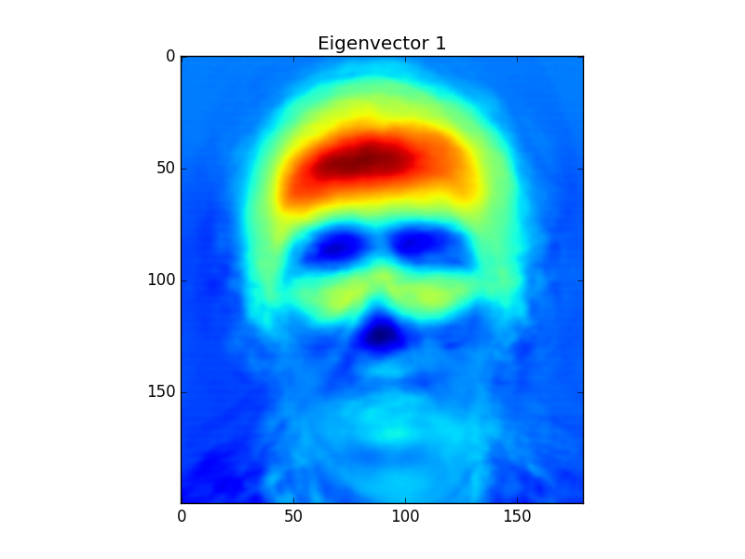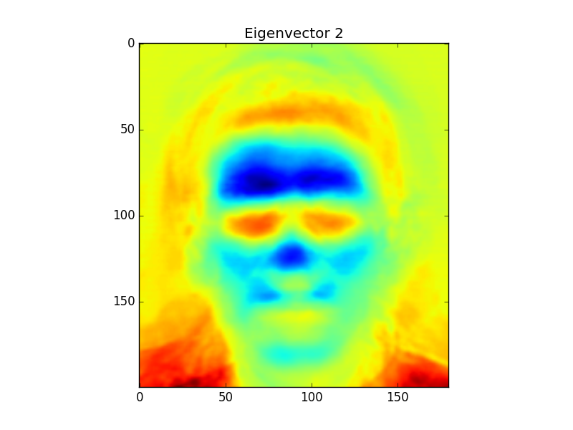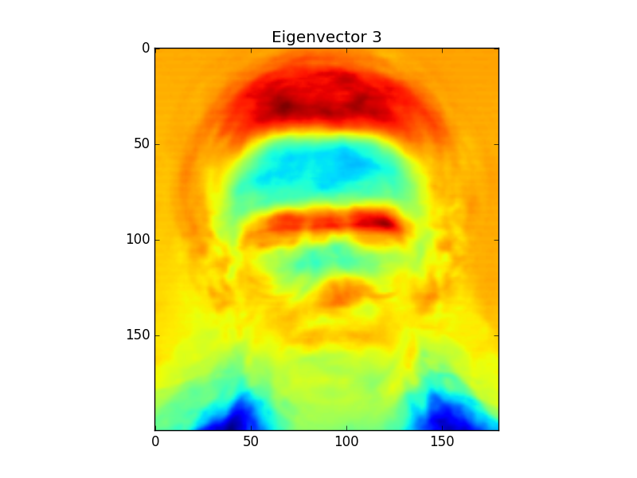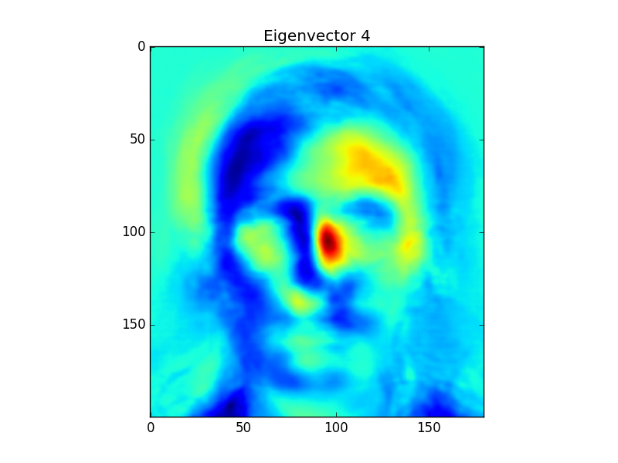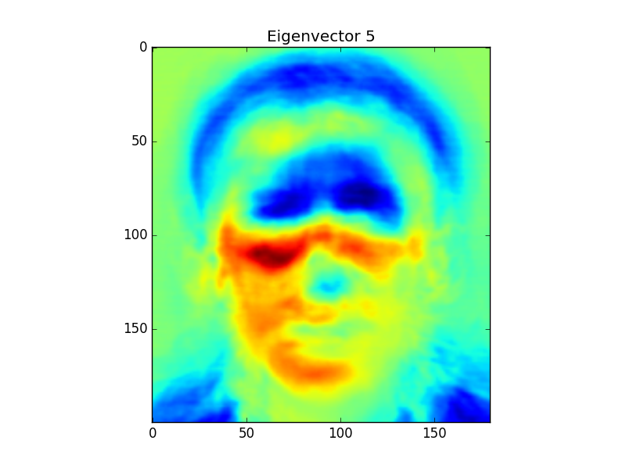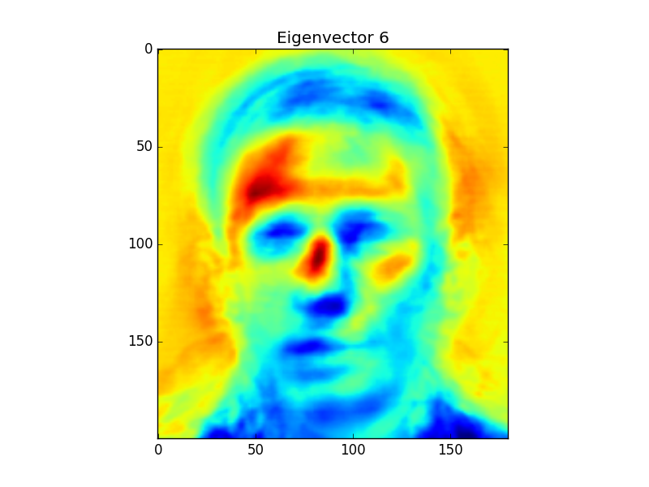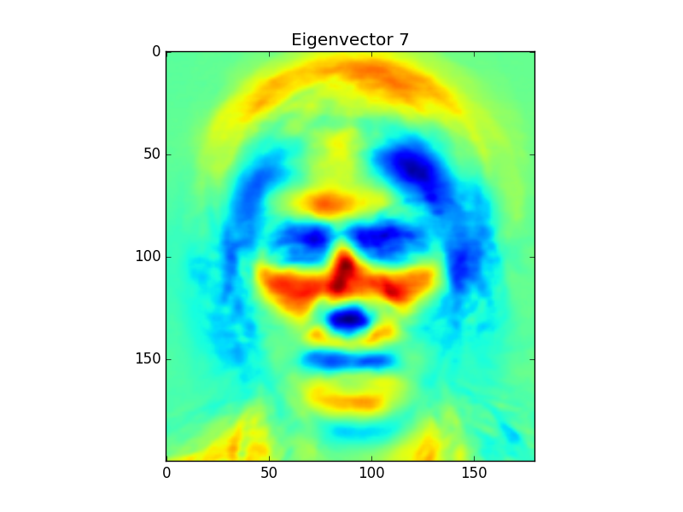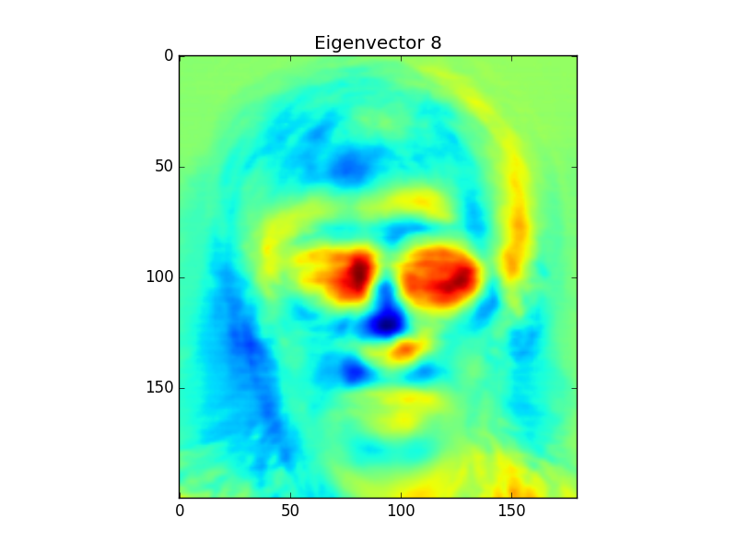

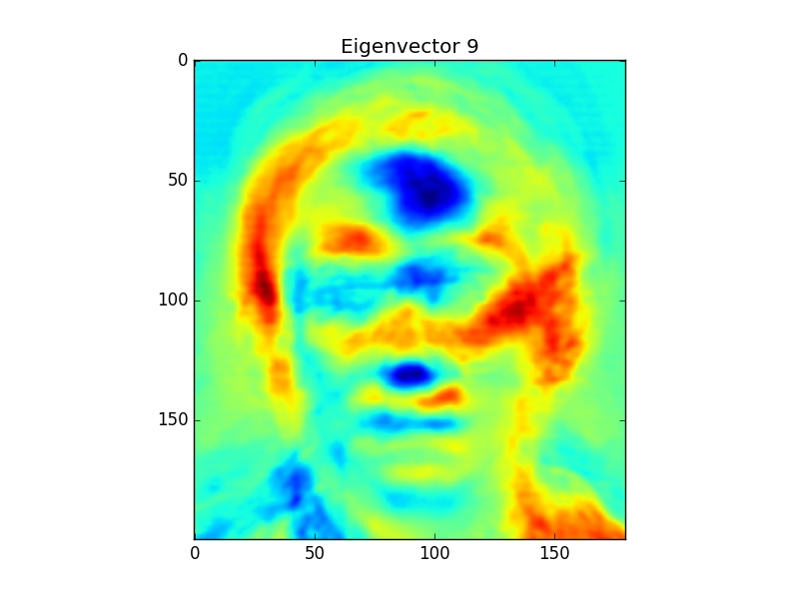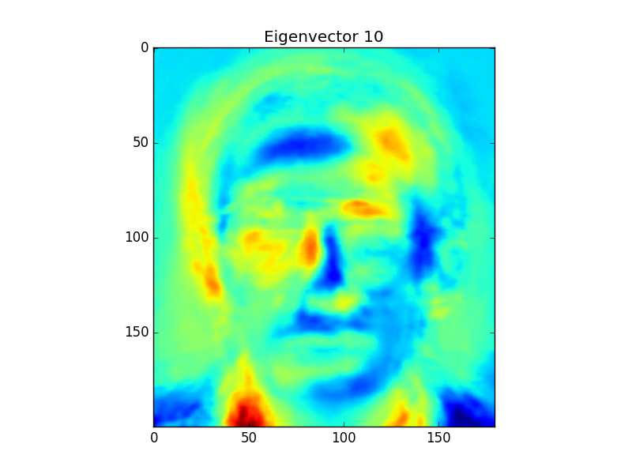

The subspace dimensionality used was 114.

Looking at the principle components above, you can see that each component describes a facial feature that is descriptive of a person. The first component shows that the forehead is very red meaning that the forehead has a lot of variance among individuals. This means that the variations in foreheads of individuals can be used as a discriminative factor in identifying an individual. Each principle component isolates a discriminative feature of an individual, where the next ones are the eyes, hair, nose jaw, cheeks, etc. These components also outline the most likely location of each of these features in an image. This means that the model has been trained to assume that people are looking forward and not tilting their heads.

Step 3

Face Reconstruction Results

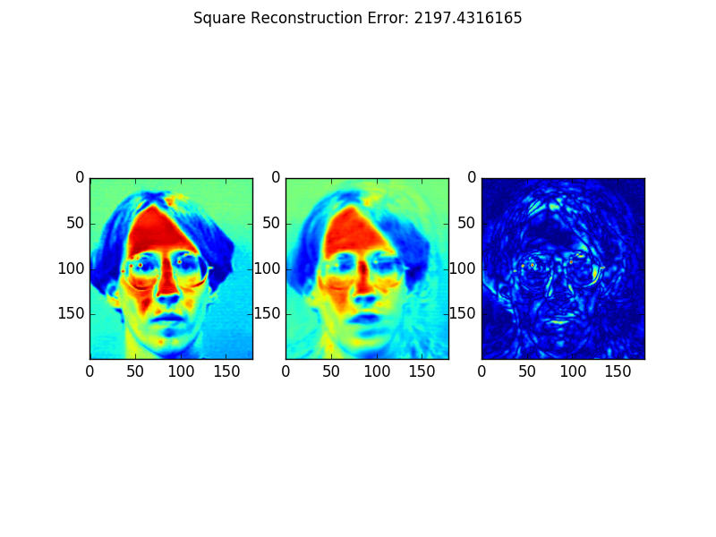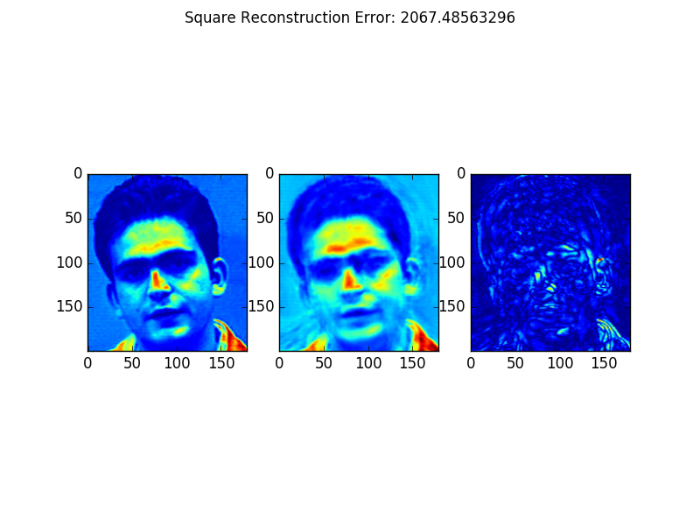

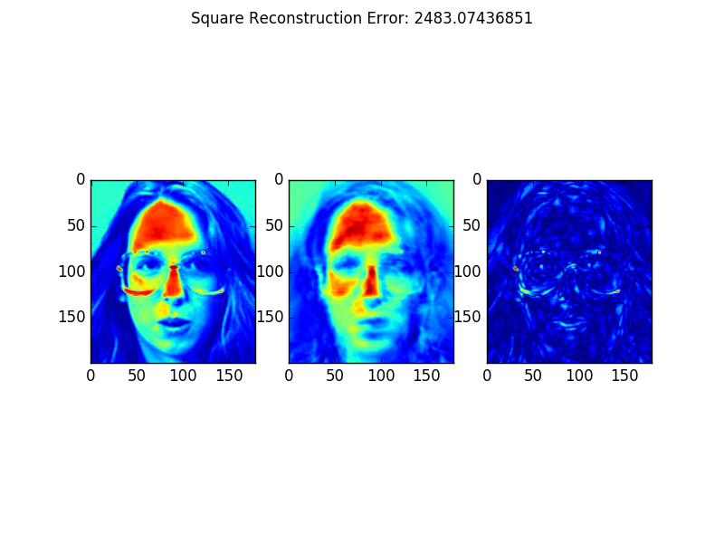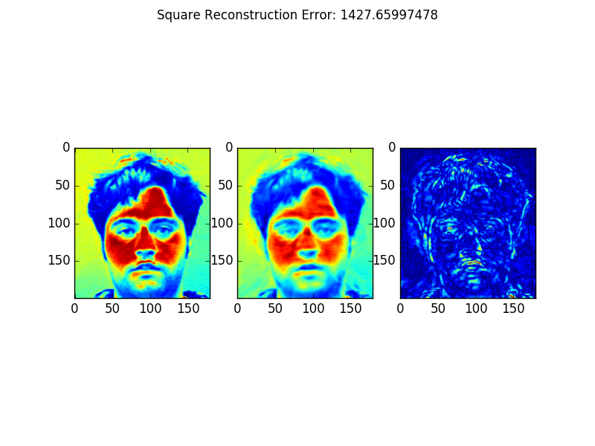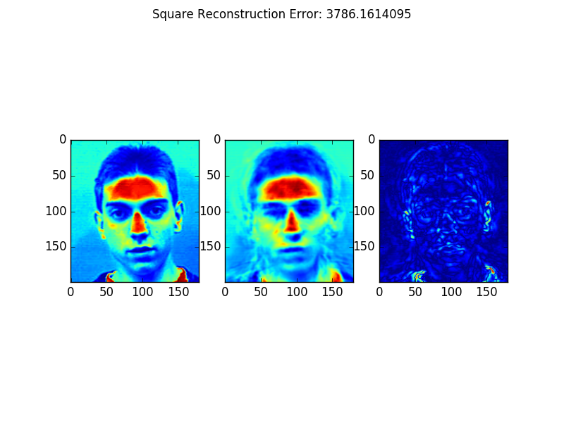

Non face Image Reconstruction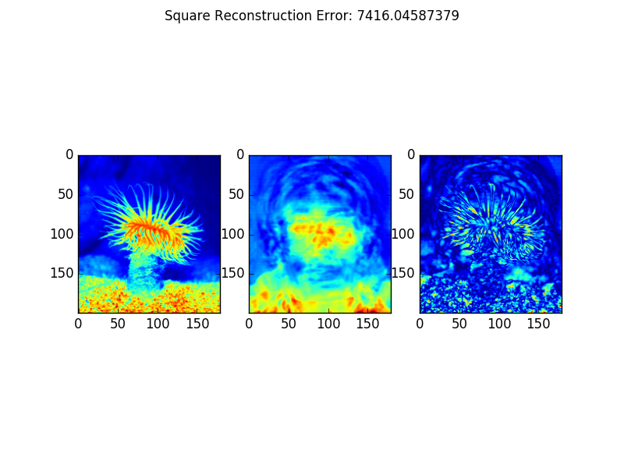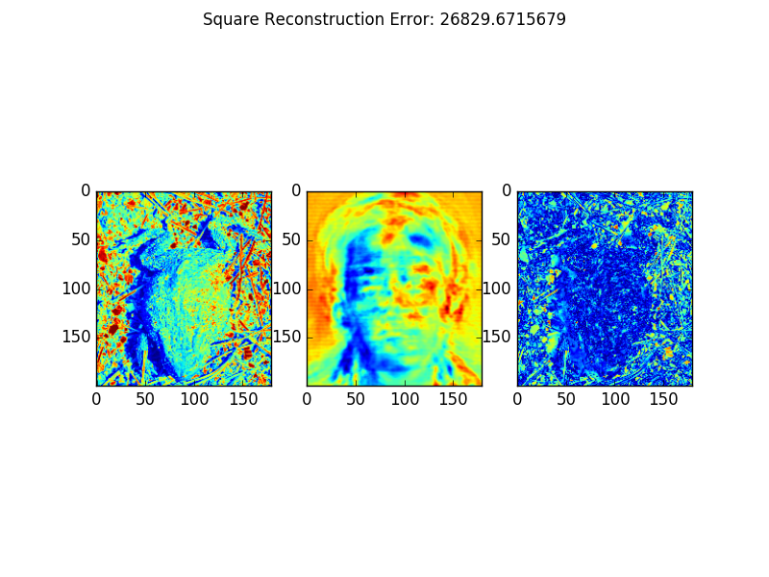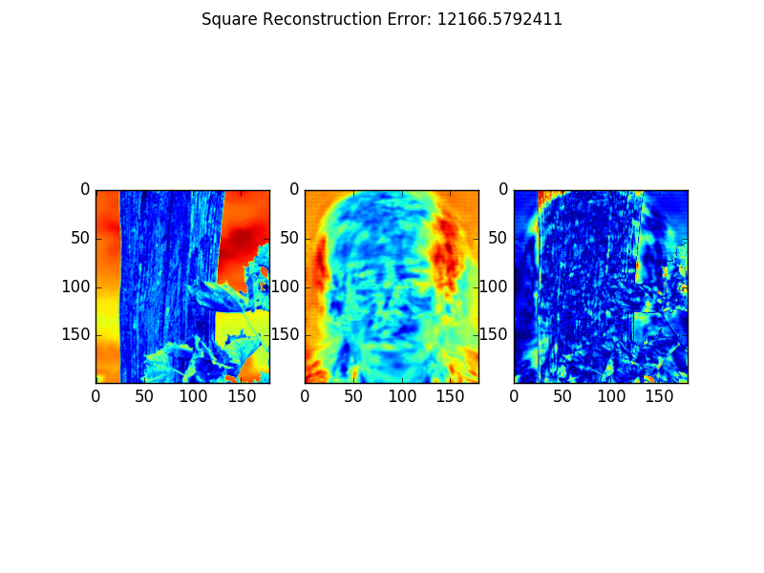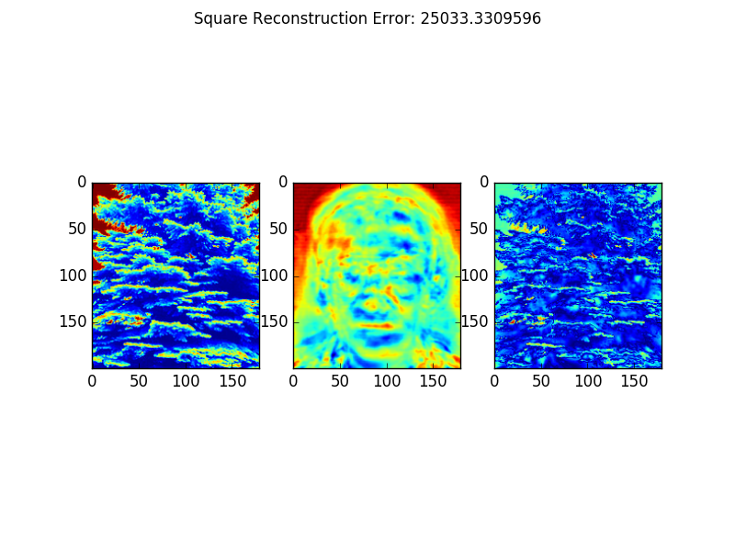

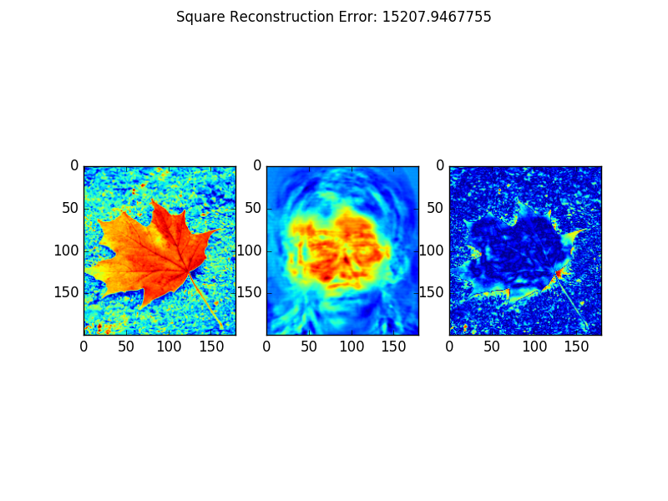

Histograms of Reconstruction Error for Face and Non Face Images

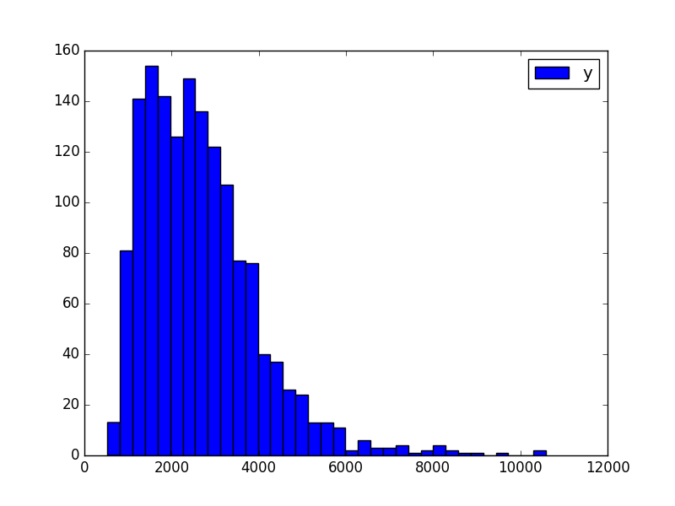

Figure . Histogram of Reconstruction Error for Face Images

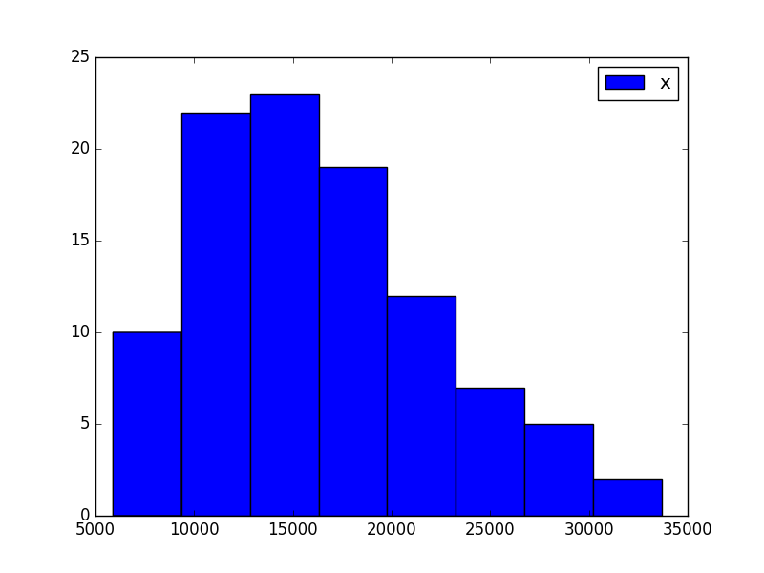

Figure . Histogram of Reconstruction Error for Non Face Images

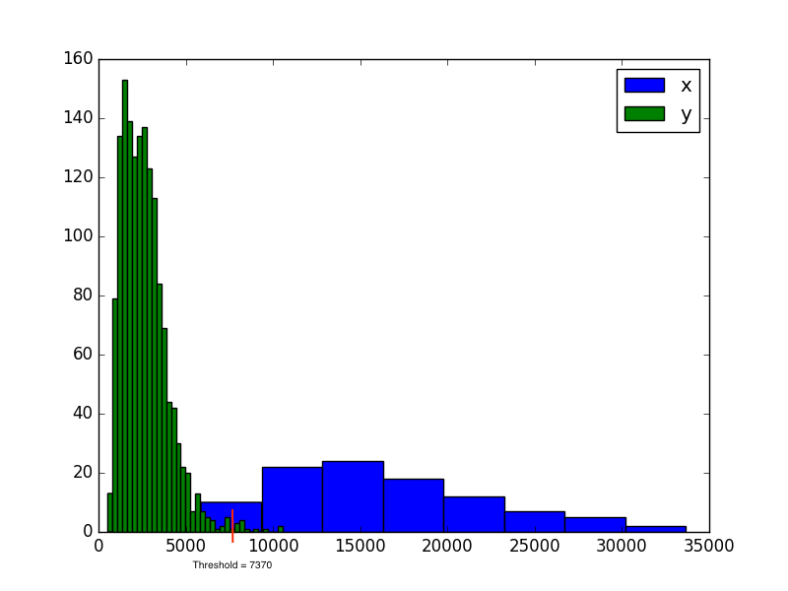

Figure . Histogram with both Face and Non Face Reconstruction Errors. Threshold value is chosen to be 7370

The chosen threshold value was 7370 after inspecting the above histogram.

Classification of Faces as Non Face Examples

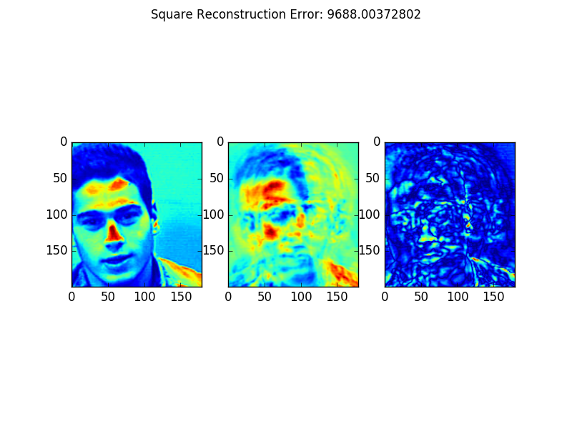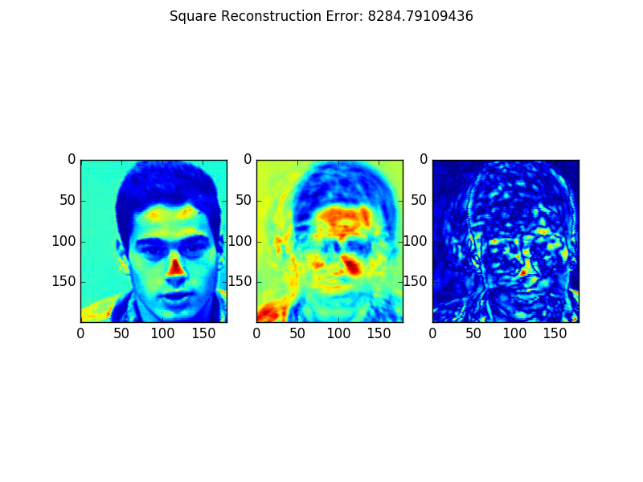

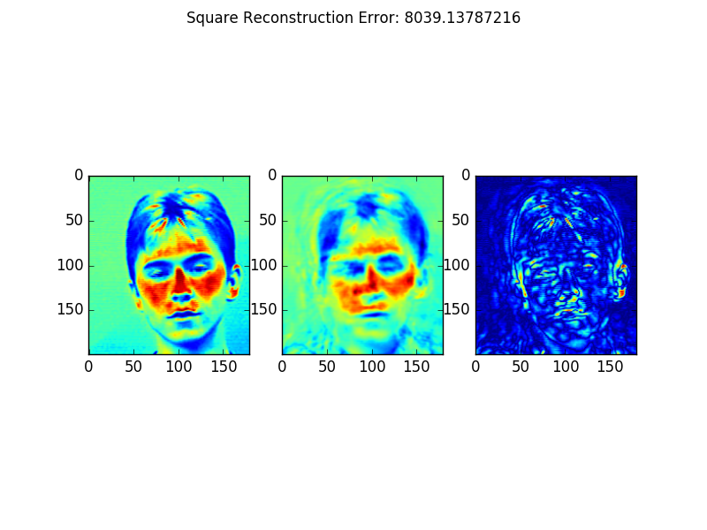

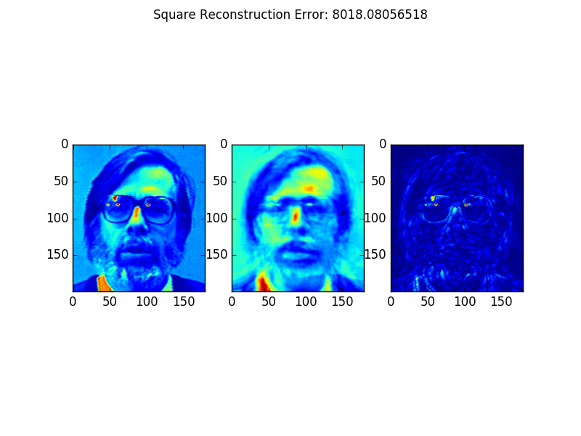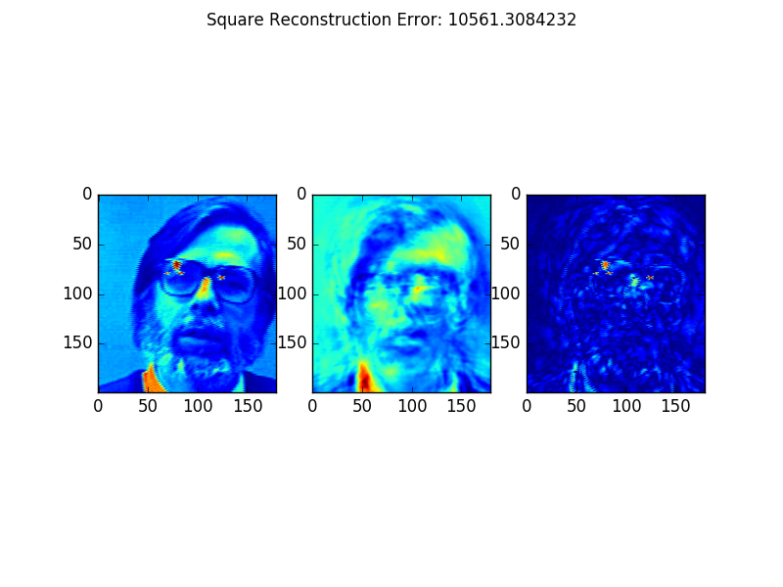

Classification of Non Face Images as Faces Examples

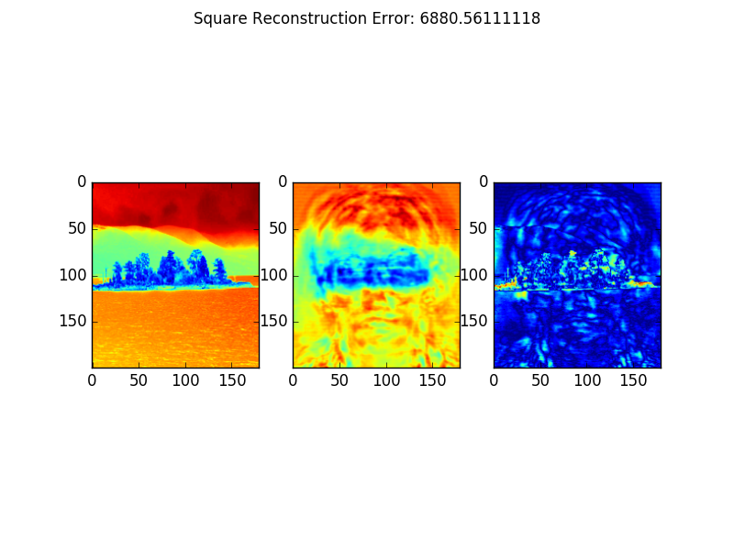

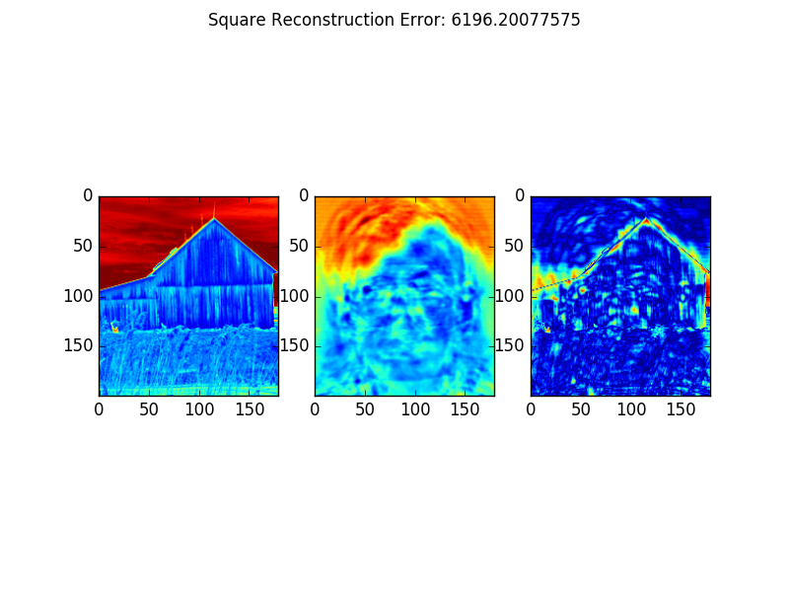

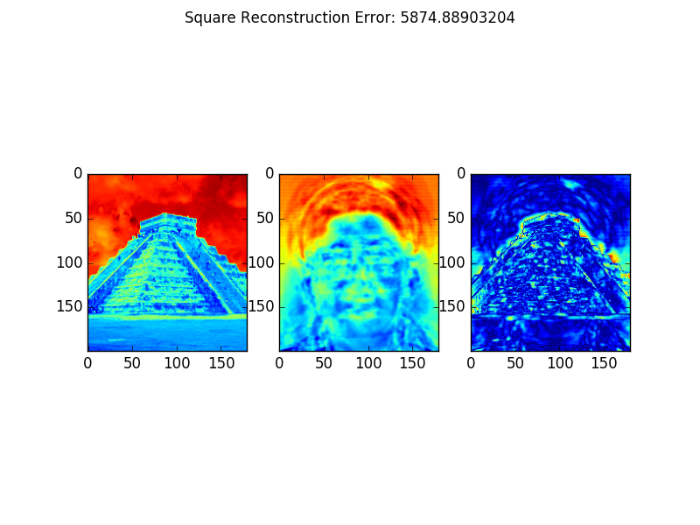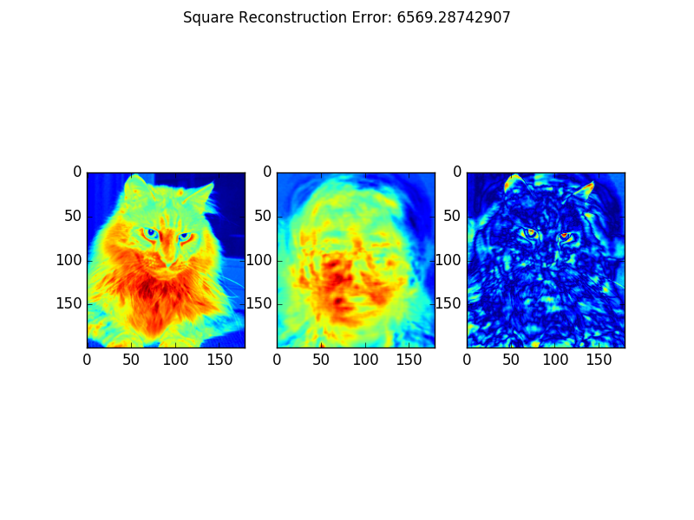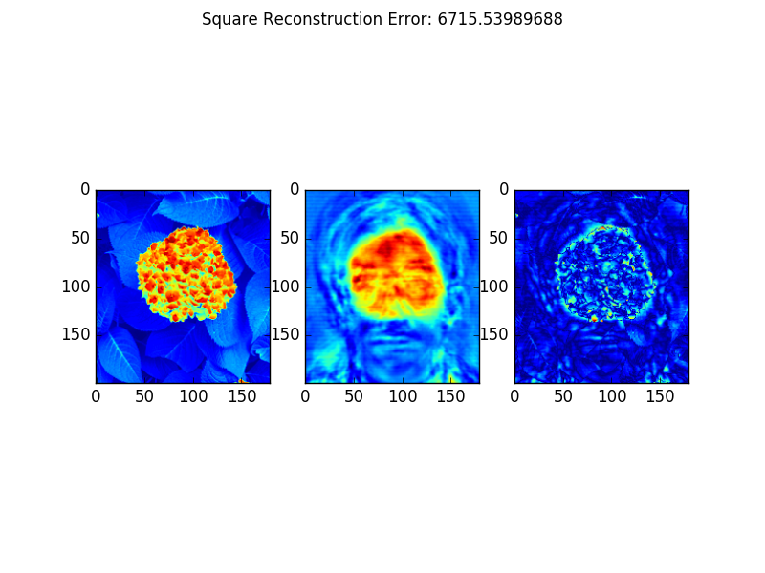

The images have been misclassified because the model has been trained to recognize faces in a very controlled environment where almost all the faces are in the centre of the image, looking straight and head not slanted. So, when there is a face that defies any of these situations, the model will have a larger reconstruction error. Looking at the first and second face false classification, we can see that since the face is not centred, looking down and slanted, there is a high reconstruction error. The third face is also slanted and has closed eyes, whereas the next two faces have very large beards and glasses. However, when looking at the falsely classified non-face images, we can see that all the images have a very central focal point, such as the cat or the pyramid. Since object are symmetric and evenly framed in the picture, this causes the classifier to think these images are faces. To prevent such an issue from occurring more faces should be included in the database with differing lighting, scale and translation.

When looking at the non-face reconstructions we can see that the reconstruction tends to look like a face. This makes sense as we are using the W and b values derived from the face data set. Since we are using the eigenvectors found from the face set, any time something revolving a facial feature is found in the non-face images, the reconstruction will try to form a face out of it. This is evident in all the examples above, but especially in the one just above, where a group of berries were turned into a face after reconstruction. There is such a large difference in reconstruction quality between the face and non-face images, because the face data set has little variance to it and is relatively controlled. With the face data set, the faces are all mostly centred in the frame, looking straight and all follow a template of two eyes, a nose, a mouth, ears, etc. Whereas, with the non-face images, there is no general structure of what the image will be like, so it is harder to generalize the data set and find the principle components that will create a seamless reconstruction.

Step 4

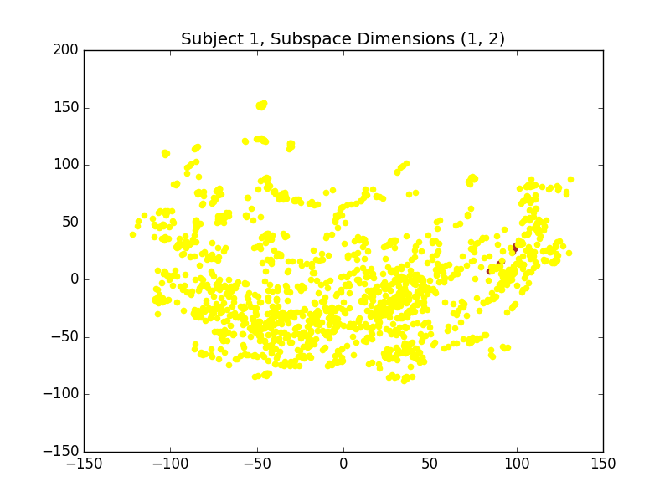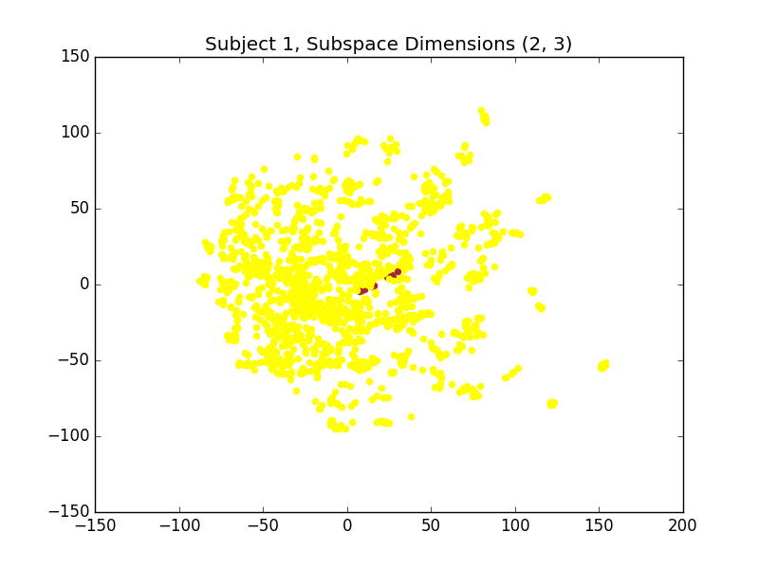

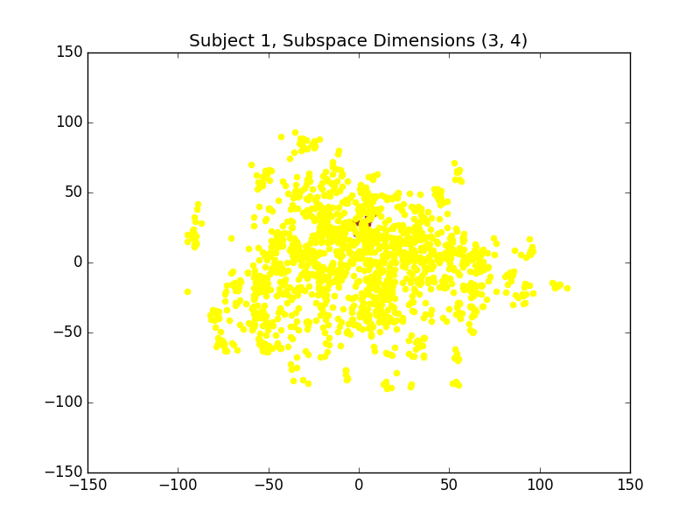

Figure . Scatter plots for Subject 1

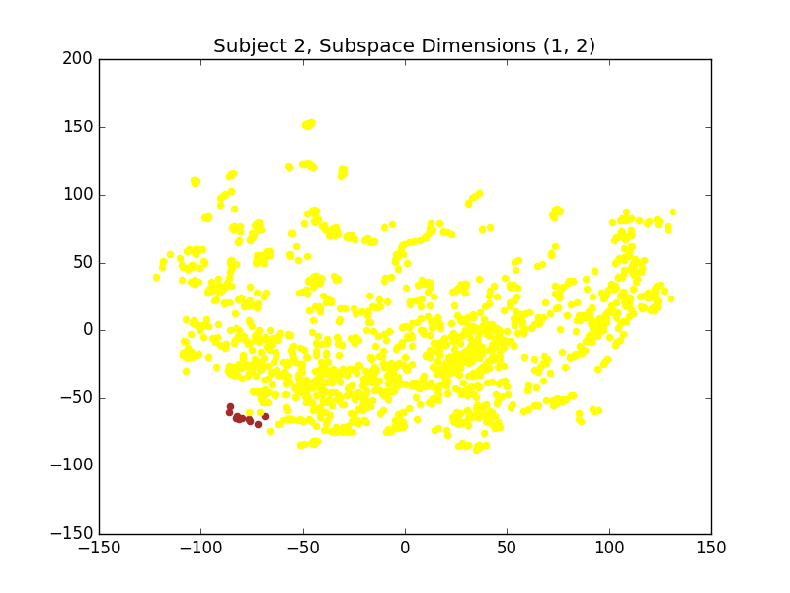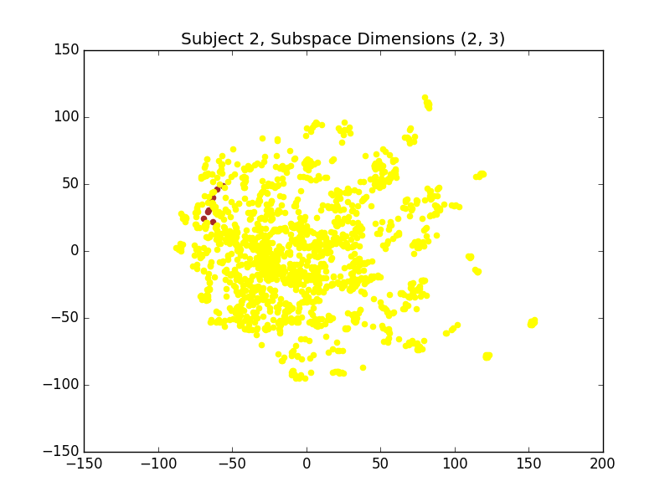

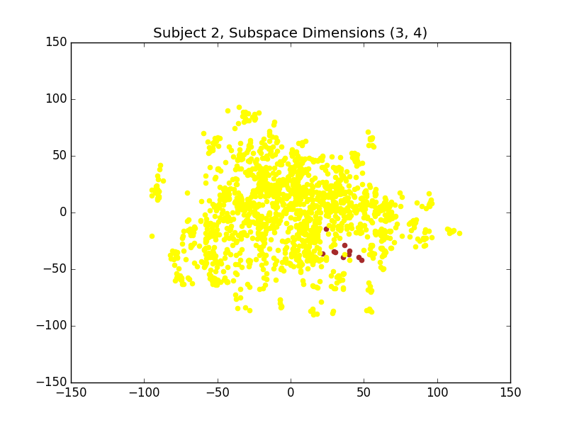

Figure . Scatter plots for Subject 2

